Pokhara University

Level: Bachelor | Semester – Spring | Year : 2007
Programme: BE |  | Full Marks: 100
Course: Electronic Circuits I |  | Time : 3hrs.

Candidates are required to give their answers in their own words as far as practicable.
The figures in the margin indicate full marks.

Attempt all the questions.

 | - “Common Collector Configuration of BJT is also called Emitter Follower”. Do you agree or disagree? Justify your answer.  - The self bias circuit is given below.  Find out:  - V_{L} / V_{S}  - Repeat part (i) if R_{E} is unbypassed.  - Give reason why V_{L} / V_{S} is low in second case.  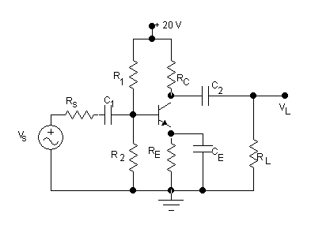  Assume R_{S} = 200Ω, R₁ = 60 KΩ, R₂ = 12 KΩ, R_{C} = 3 KΩ, R_{E} = 1 K Ω, R_{L} = 4 KΩ., V_{S} = 1 mV rms.  = 90, r_{e} = 20 Ω, C₁ = C₂ = 25 F, C_{E} = 100F. | 7  3  4  1
 | - Define the following terms: Lower Cut off Frequency, Upper cut off frequency, and bandwidth. Draw Gain versus frequency plot of circuit (Q.No.1.b) and explain why gain is low at lower frequencies.  - Derive the expression of efficiency of transformer coupled load class A power amplifier in which condition the efficiency becomes maximum possible? | 2+5  6+2
 | - What are the main advantages and disadvantages of negative feedback? Negative feedback improves SNR (signal to noise ratio).Verify it.  - What are the main conditions of oscillation? Draw RC phase shift oscillator that oscillates at 300 Hz. | 3+4  2+4+2
 | - Draw full wave bridge rectifier circuit and explain its operation. Derive the expression of its average output voltage.  - What do you mean by regulated power supplies? Draw any one regulator circuit and explain its operation. | 2+3+2  4+4
 | - Draw simple integrator circuit and derive the expression of its output voltage.  - Considering a finite gain of an operational amplifier, derive the transfer functions for both the inverting and non-inverting amplifier.  OR  - Draw n-stages cascaded amplifier and derive the expression of its overall voltage gain.  - For the circuit given in Q. No. 1b, find the value of lower cut off frequency. | 7  8  7  8
 | - Explain the importance of analog to digital conversion and vice versa. Draw Binary weighted resistor DAC and explain its operation.  - Draw Counting Type ADC and explain its operation.  OR  - Draw Darlington pair amplifier and derive the expression of its effective current gain.  - What are the various types of negative feedback configurations? Explain them briefly. | 3+4  8  7  8
 | Write short notes on (Any Two):  - Cross over distortion  - Crystal oscillator  - Efficiency of half wave and full wave rectifiers | 2×5

